

NOTRE DAME UNIVERSITY
BANGLADESH
CSE-3104 LAB Report-03

Course Title: Compiler Design Lab
Course Code: CSE-3104

Submitted by:
Name: Istiak Alam
ID: 0692230005101005
Batch: CSE-20
Submission Date: 24-11-24
Lab Task Topic: Compiler Problem Solving using Lex

Submitted to:
Khorshed Alam
Lecturer, NDUB
Problem:
Write a YACC program to implement Grammar for a simple calculator.

Solution:

Code : –

%{
#include <stdio.h>
#include <string.h>
#include <ctype.h>

int num_lines = 1; // Counter for line numbers
int symbol_table[100]; // Simple array to simulate symbol table for numbers
int sym_index = 0; // Index for symbol table

// Function to check if a string is a keyword
int is_keyword(char* str) {
char* keywords[] = {"program", "if", "not", "end", "begin", "else", "then",
"do", "while", "function", "Procedure", "integer",
"int", "real", "var", "oh", "array", "write"};
int num_keywords = 18; // Total number of keywords
for (int i = 0; i < num_keywords; i++) {
if (strcmp(str, keywords[i]) == 0) {
return 1; // It's a keyword
}
}
return 0; // Not a keyword
}

%}

%%

//Ignoring whitespaces (space, tab, newline, etc.)
[ \t]+ { /* Ignore whitespaces */ }

/*Count lines based on newline characters*/
\n { num_lines++; }

/*Matching keywords and identifiers (variables start with a letter or underscore)*/
[_a-zA-Z][_a-zA-Z0-9]* {
if (is_keyword(yytext)) {
printf("Keyword: %s at line %d\n", yytext, num_lines);
} else {
printf("Identifier: %s at line %d\n", yytext, num_lines);
}
}

/*Matching numbers and inserting them into the symbol table*/
[0-9]+ {
symbol_table[sym_index++] = atoi(yytext);
//atoi() converts an integer value from a string of characters
printf("Number: %s inserted in symbol table at line %d\n", yytext, num_lines);
}

/*Relational Operators*/
"=" { printf("Relational Operator: = at line %d\n", num_lines); }
"<>" { printf("Relational Operator: <> at line %d\n", num_lines); }
"<=" { printf("Relational Operator: <= at line %d\n", num_lines); }
">=" { printf("Relational Operator: >= at line %d\n", num_lines); }
"<" { printf("Relational Operator: < at line %d\n", num_lines); }
">" { printf("Relational Operator: > at line %d\n", num_lines); }

/*Addition, Subtraction, Multiplication, and Division operators*/
"+" { printf("Addition Operator: + at line %d\n", num_lines); }
"-" { printf("Subtraction Operator: - at line %d\n", num_lines); }
"*" { printf("Multiplication Operator: * at line %d\n", num_lines); }
"/" { printf("Division Operator: / at line %d\n", num_lines); }

/*Catch-all for other characters (optional)*/
. { printf("Unrecognized character: %c at line %d\n", yytext[0], num_lines); }

%%

int main() {
printf("Starting lexical analysis...\n");
yylex(); // Start the lexical analysis
printf("Lexical analysis complete.\n");
return 0;
}

Code Processing –
Step 1 : Open terminal in Linux and create a lex file named analyzer.l
⇒ touch analyzer.l
Step 2 : After Writing the code save it and type command in terminal :
⇒ lex analyzer.l
Step 3 : It will create a lex.yy.c file. Then next type command in terminal :
⇒ cc lex.yy.c -o analyzer -ll
Step 4 : Then it will create an executable file named analyzer.exe.
Step 5 : Next type command in terminal and run the exe file :
⇒ ./analyzer < input.txt

Input and Output:

- We are using input.txt file for checking out inputs in this lexical analyzer.
- In the input.txt file there are a simple program language –

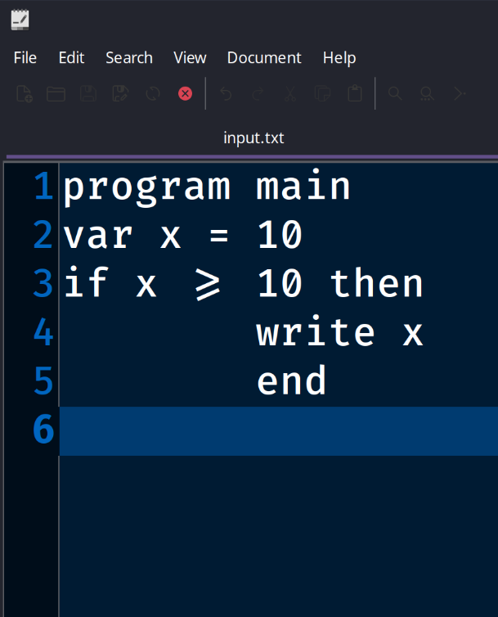

- After injecting the input, the output is –

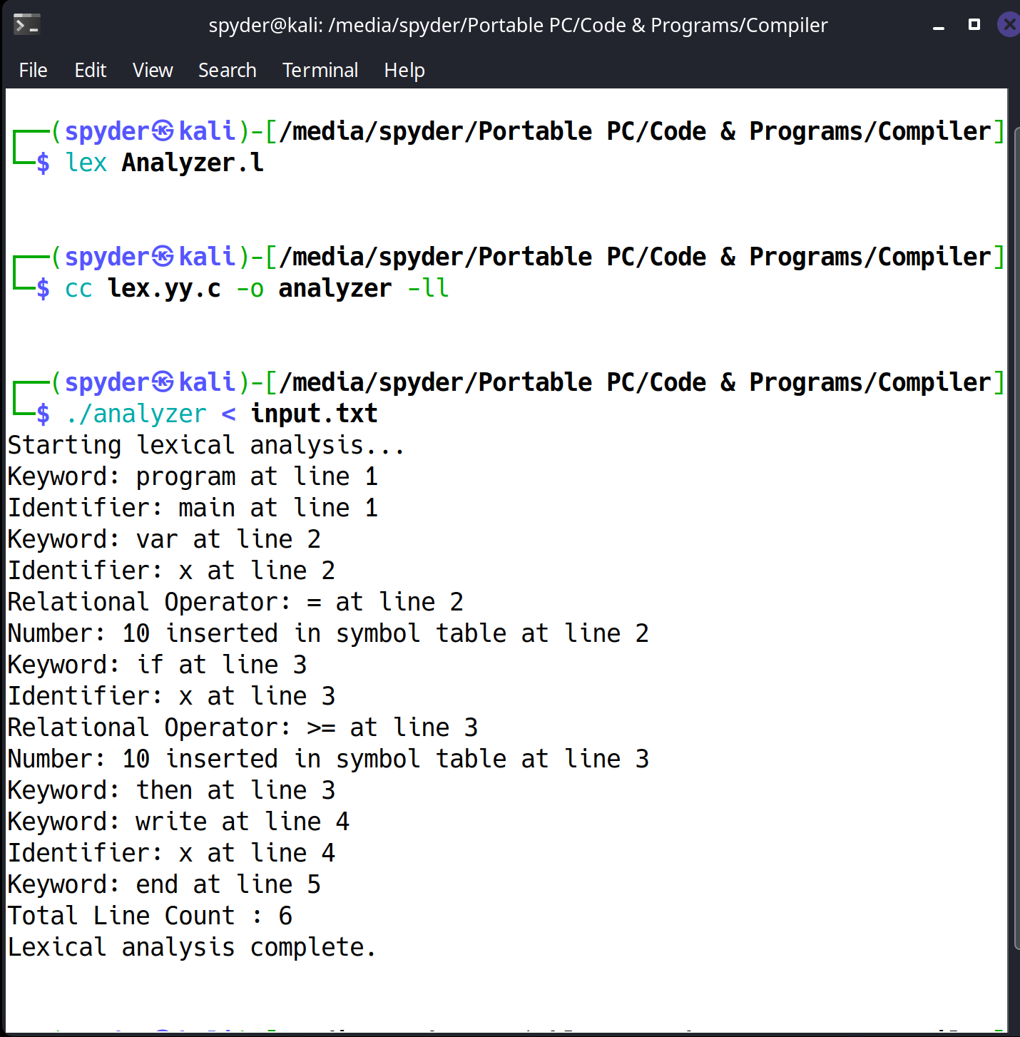

Output

